# Diary Development Notes

Week 1

## Monday (6-March-2022)

* Explore the unit guideline and MS Team
* Go through MS team to read any announcements from the unit chair

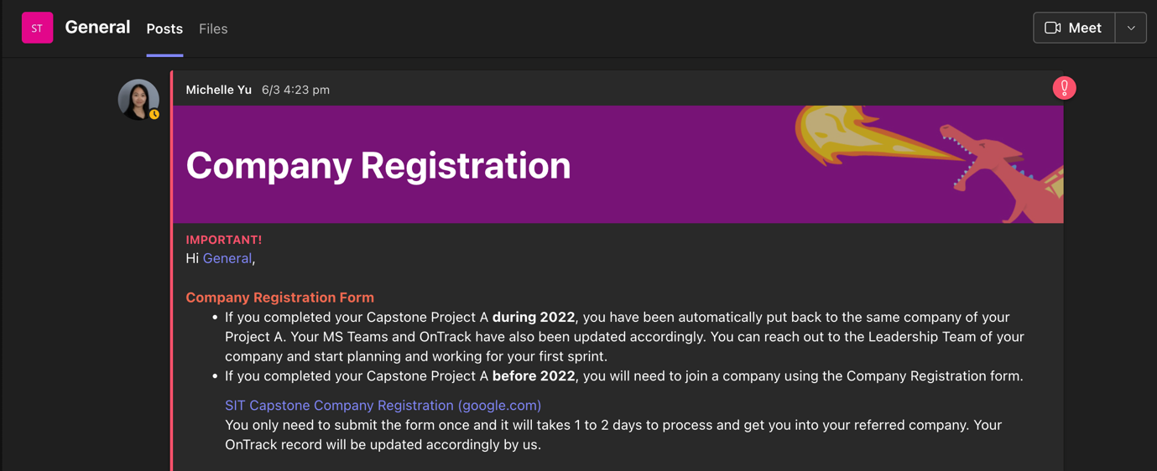

Figure : Announcement from the unit chair related to the Company Registration

## Tuesday (7-March-2022)

* Join the Week 1 Lecture Class

## Wednesday (8-March-2022)

* Have a conversation with Chanputhi who is a part of Project Lead team to discuss about the role and position in the Gopher company

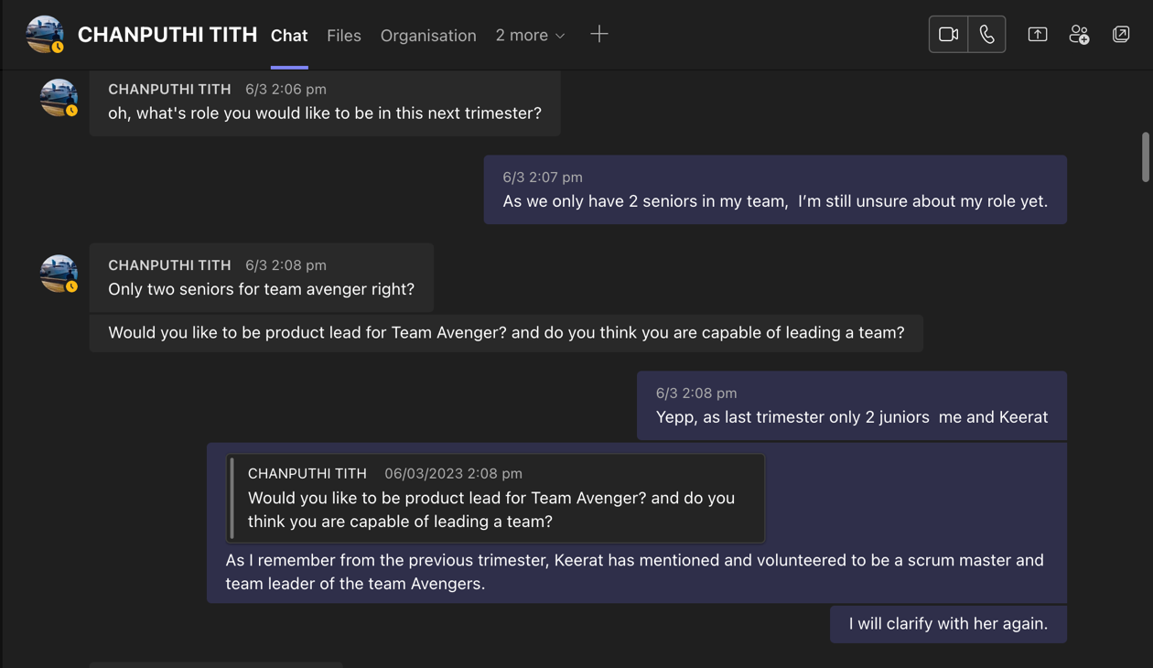

Figure : Discuss with Chanputhi about the company progression and relevant information

* Rewatch the first senior meeting catch up Round 1

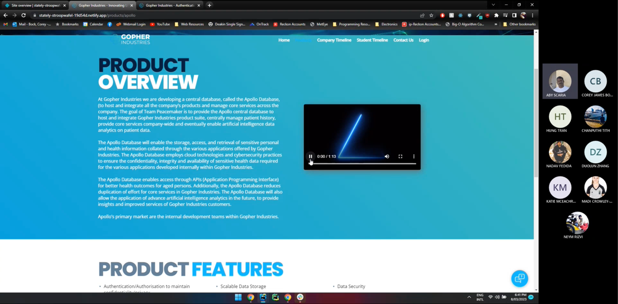

Figure : Senior meeting catch up round 1

## Thursday (9-March-2022)

* Rewatch the senior meeting round 2

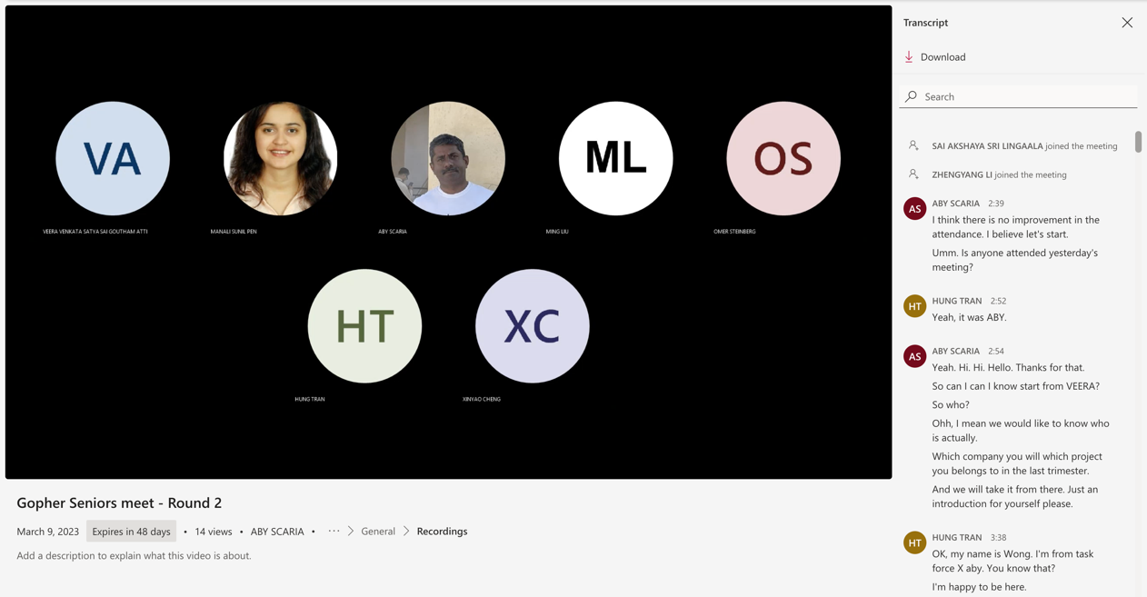

Figure : Senior meeting round 2

Week 2

## Tuesday (14-March-2022)

* Complete the Project and Team role selection form for T1

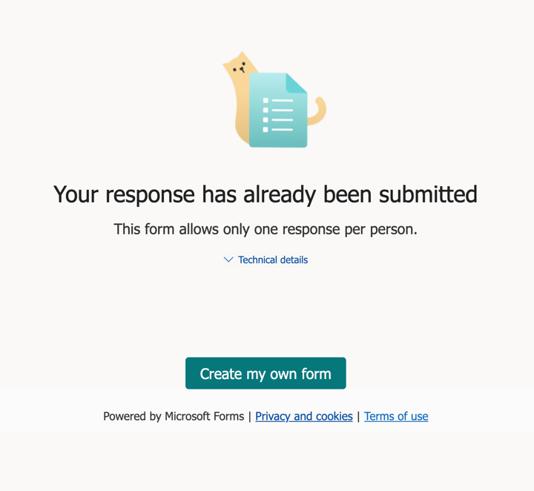

Figure : Completed the role selection form

* Join the Week 2 Lecture Class

## Thursday (16-March-2022)

* Join the Gopher Industries meeting with all Seniors and Juniors

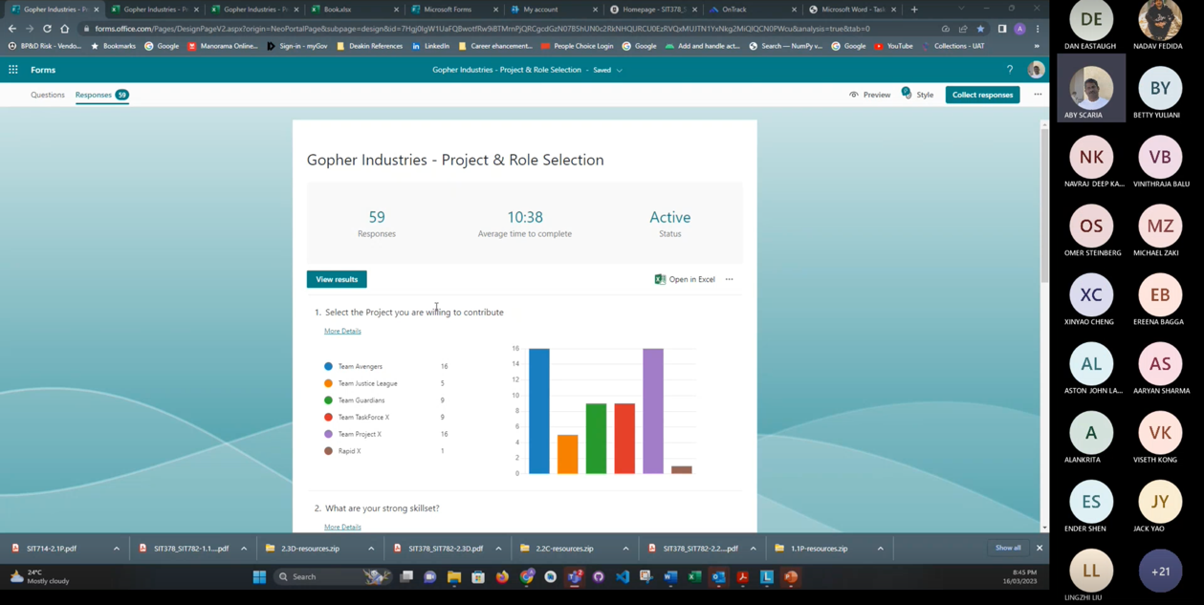

Figure : Meeting with all members of Gopher Comapany

## Friday (17-March-2022)

* Complete task 1.1p and 2.1c

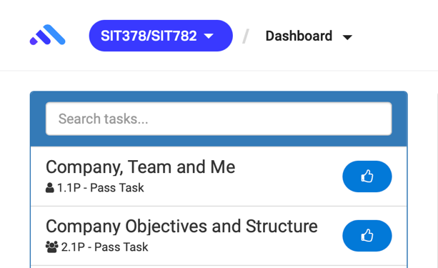

Figure : Ontrack Submission

Week 3

## Tuesday (21-March-2022)

* Join the Week 3 Lecture Class

## Wednesday (22-March-2022)

* Join the first Meeting with Team Project X and get to know each other

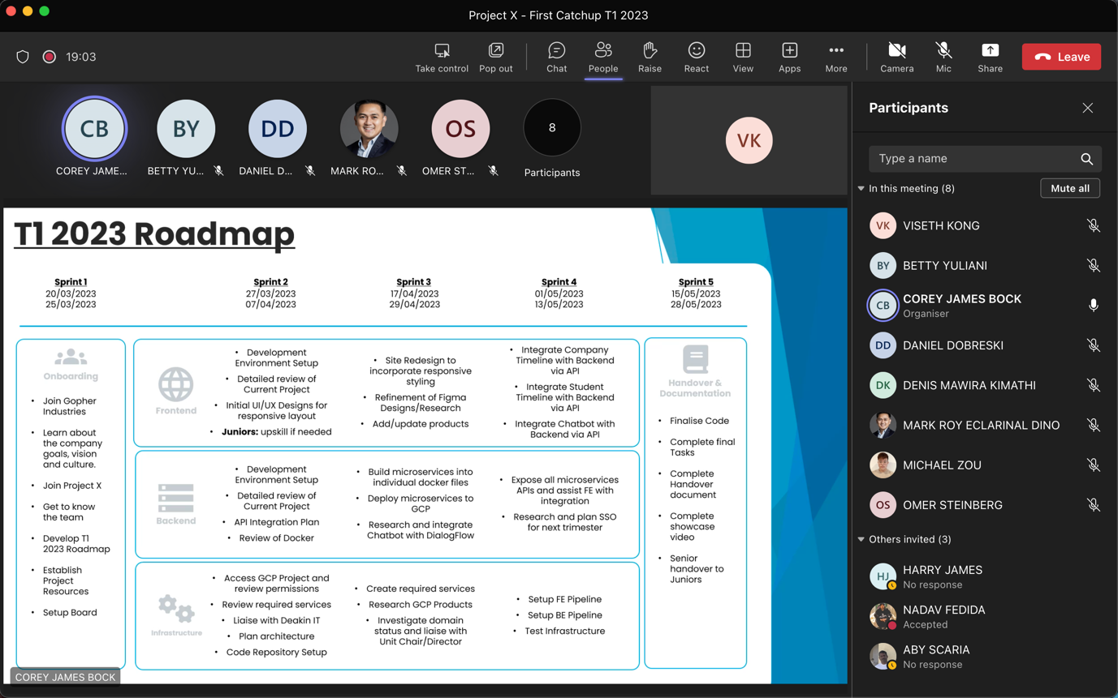

Figure : First meeting with Team Project X

* Project X meeting minutes: <https://deakin365.sharepoint.com/sites/GopherIndustries2/Shared%20Documents/Forms/AllItems.aspx?id=%2Fsites%2FGopherIndustries2%2FShared%20Documents%2FProject%20X%20%28Coming%20Soon%29%2FT1%202023%2FMeeting%20Minutes%2F1%2E%20Project%20X%20Meeting%20Minutes%2022%2E03%2E23%20First%20Meeting%2Epdf&parent=%2Fsites%2FGopherIndustries2%2FShared%20Documents%2FProject%20X%20%28Coming%20Soon%29%2FT1%202023%2FMeeting%20Minutes>

## Thursday (23-March-2022)

* Get familiarise with the team environment and review some of the previous document from T3 such as project handover document and video demonstration.

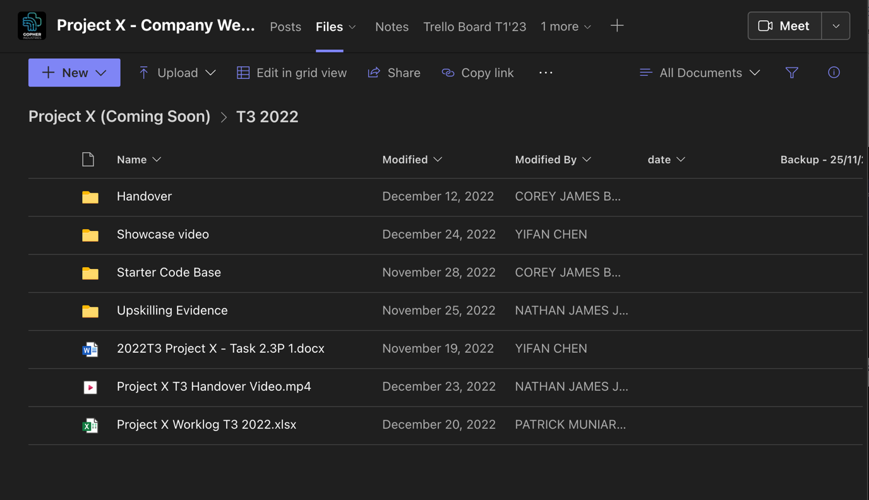

Figure : Handover document folder from previous trimester that I need to review

* Set up project folder into local computer, worklog, and daily development note

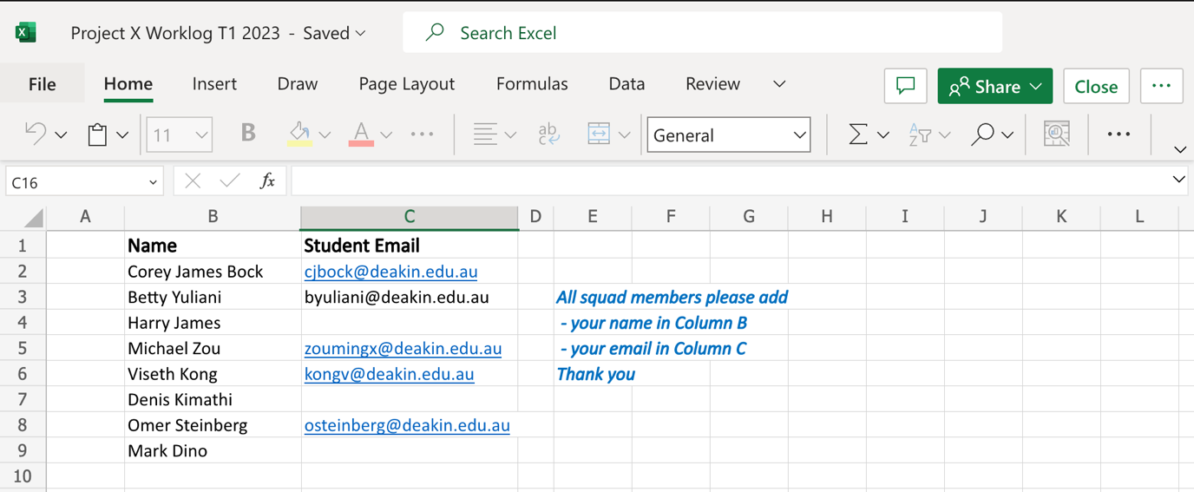

Figure : Our team worklog and attendance log for this trimester

* Response to team leader related to my experiences in coding and the role I prefered for this trimester

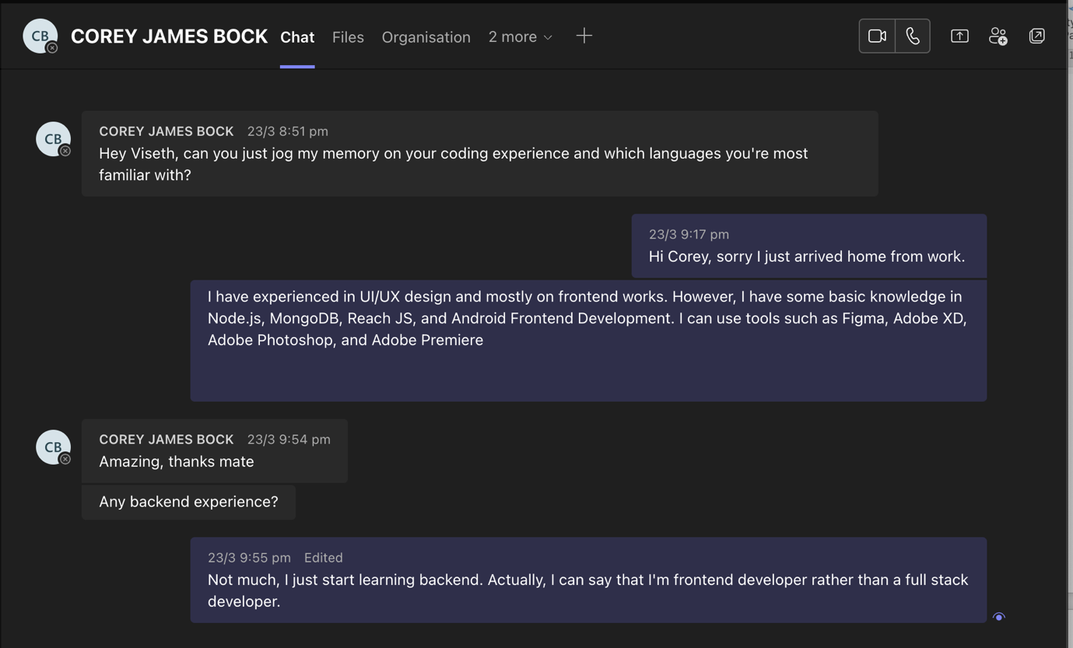

Figure : Have some conversation with team leader about the role in the project

## Friday (24-March-2022)

* Document Project Resources Link on GitHub

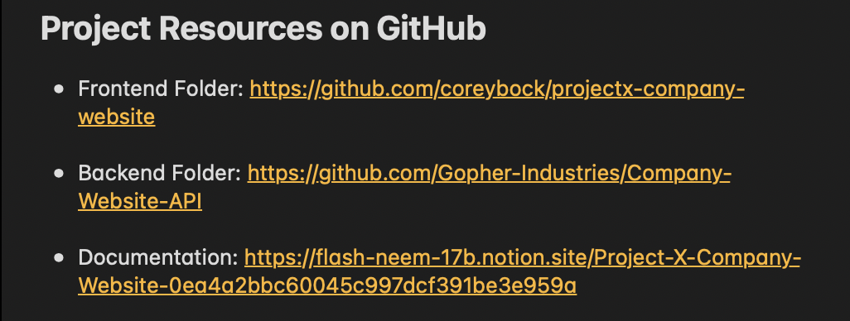

Figure : GitHub Resources

* Research and found some essential resources related to the project’s upskilling

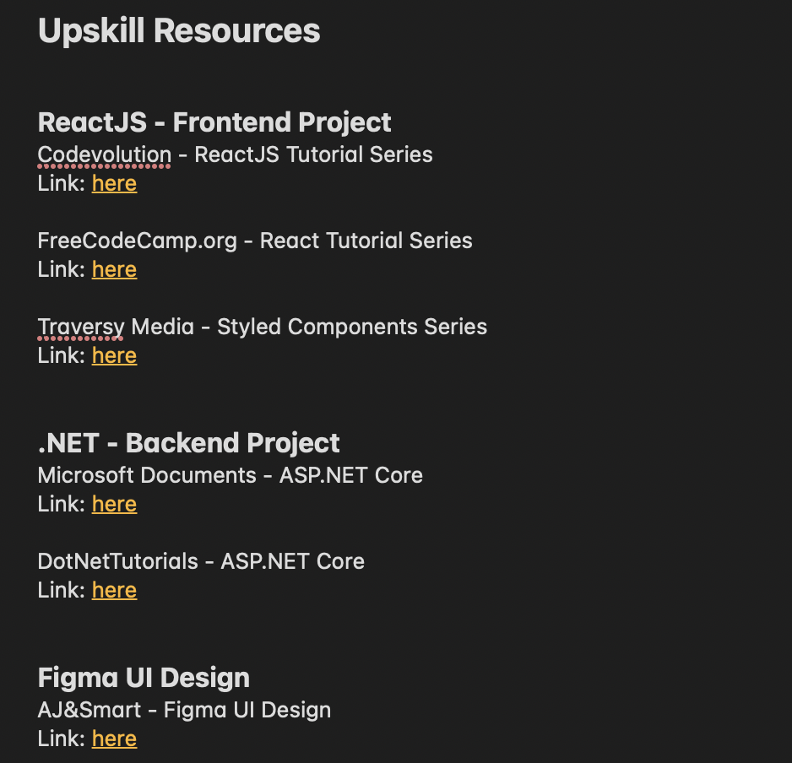

Figure 14: Some resources I found in google which related to my project

Week 4

## Monday (27-March-2022)

* Join Sprint planning Meeting with Team Project X.

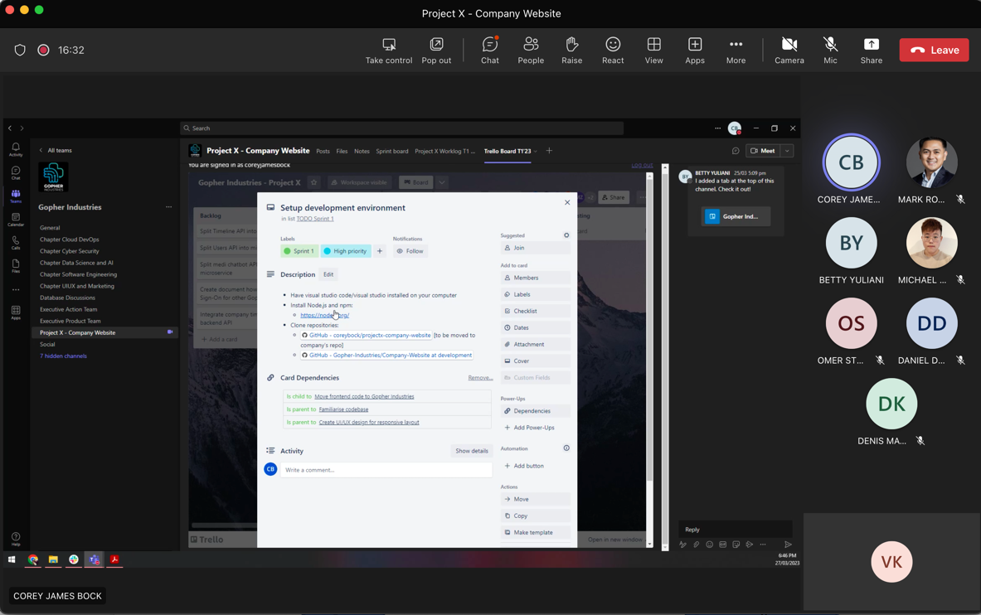

Figure : Sprint planning meeting

* Join Project X’s Trello board and read through the assigned task for this week

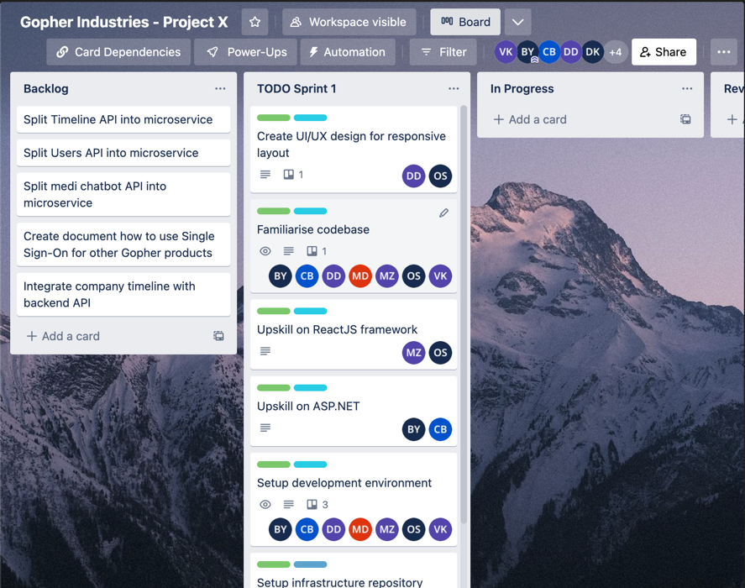

Figure : Project X's Trello board

* Project X meeting minutes: <https://deakin365.sharepoint.com/sites/GopherIndustries2/Shared%20Documents/Forms/AllItems.aspx?id=%2Fsites%2FGopherIndustries2%2FShared%20Documents%2FProject%20X%20%28Coming%20Soon%29%2FT1%202023%2FMeeting%20Minutes%2F2%2E%20Project%20X%20Meeting%20Minutes%2027%2E03%2E23%20Sprint%20Planning%20Meeting%2Epdf&parent=%2Fsites%2FGopherIndustries2%2FShared%20Documents%2FProject%20X%20%28Coming%20Soon%29%2FT1%202023%2FMeeting%20Minutes>

## Tuesday (28-March-2022)

* Join the Week 4 Lecture Class
* Setup development environment, cloned the project website and looked through the project code

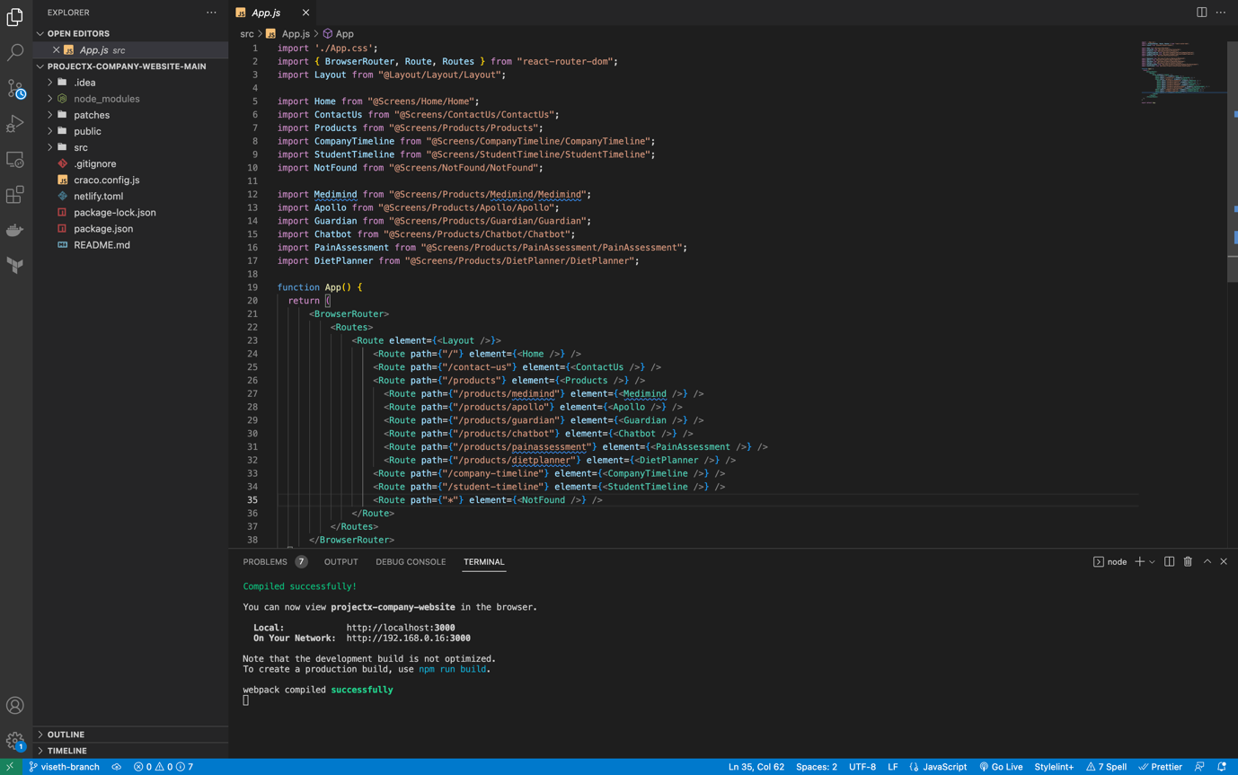

Figure : Frontend website code folder

* Run and tested the website on my local computer

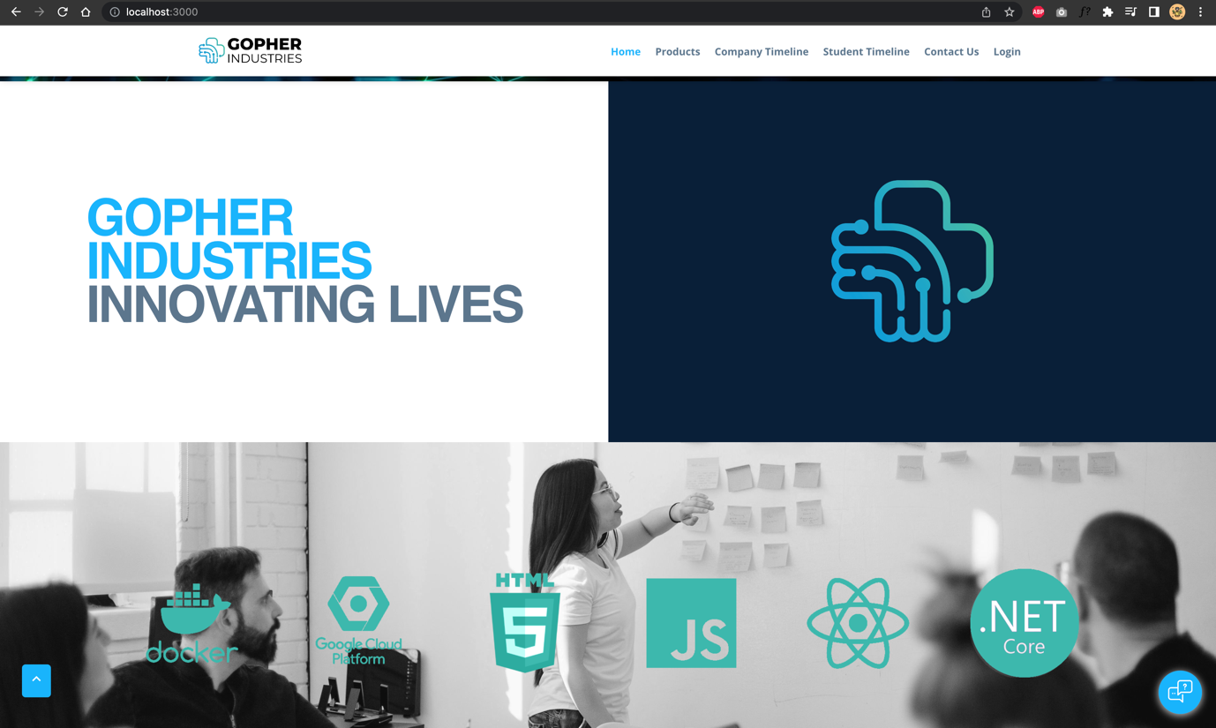

Figure : Run the website on my local machine

* Informal Standup to provide my progress report:

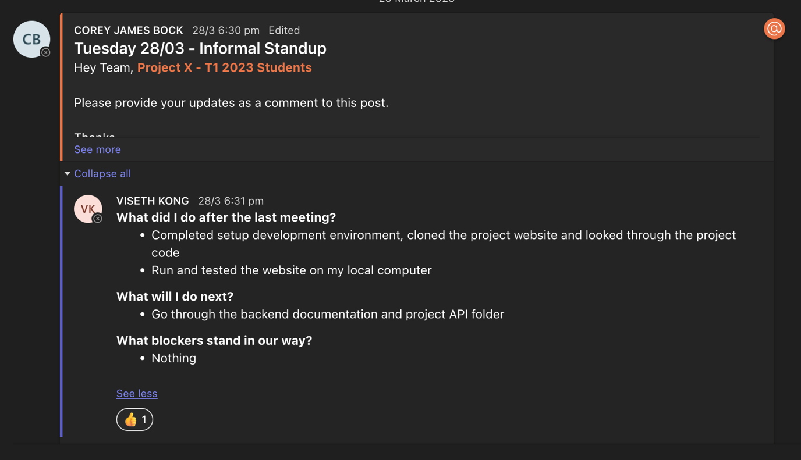

Figure : Progress report

## Wednesday (29-March-2022)

* Upskill on React fundamental through YouTube and various website, then start to create a basic website using react

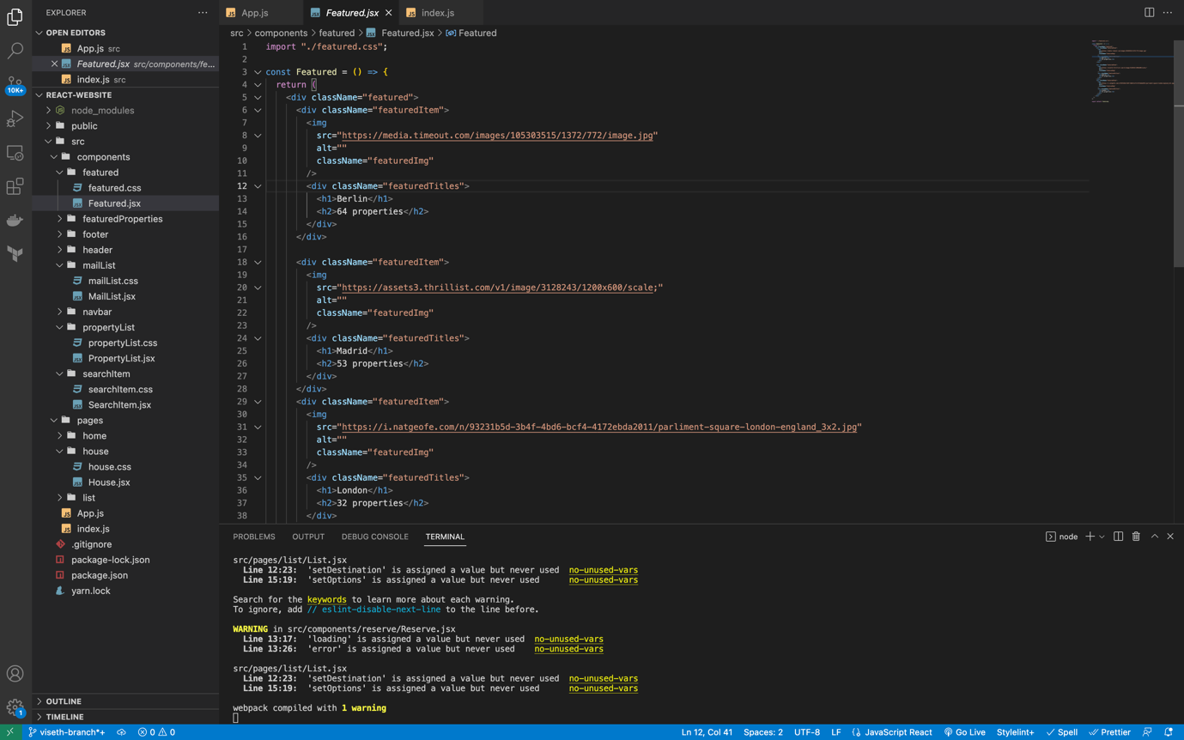

Figure : Create a basic React website

* Read through the notion backend and API documentation

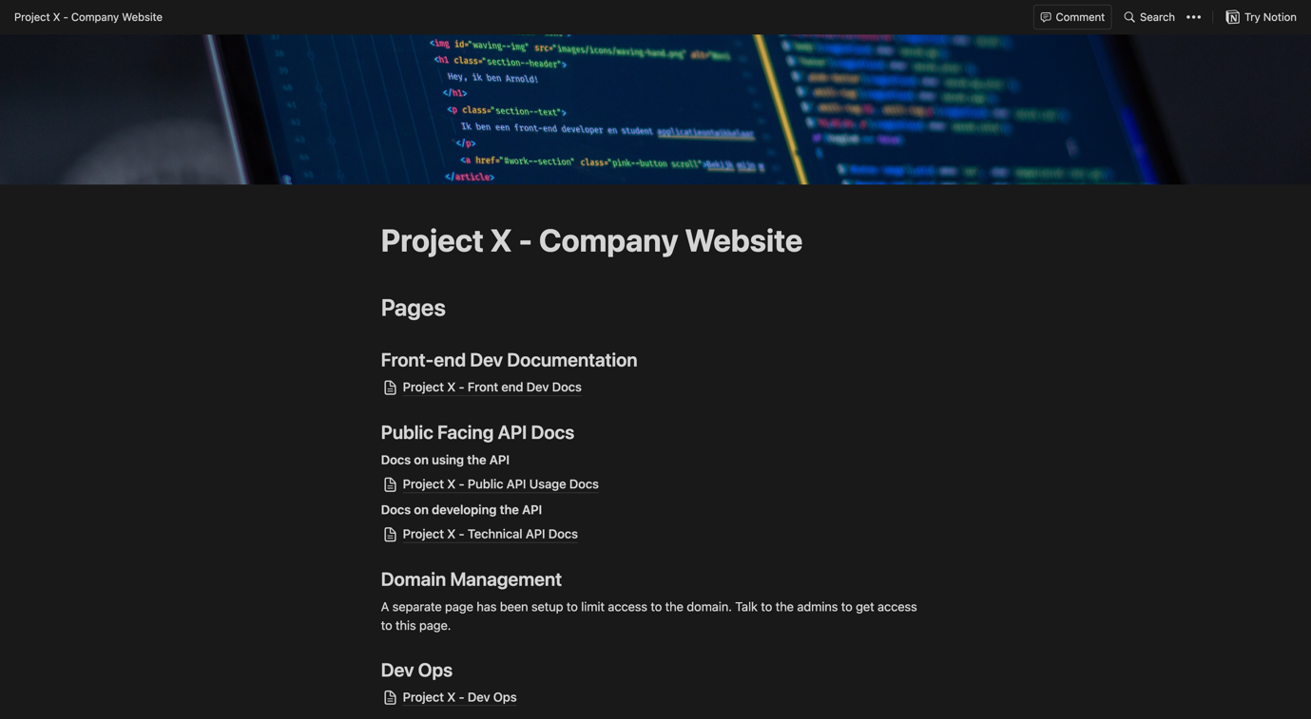

Figure : Read through the API documentation provided by previous senior member

* Informal Standup to provide my progress report:

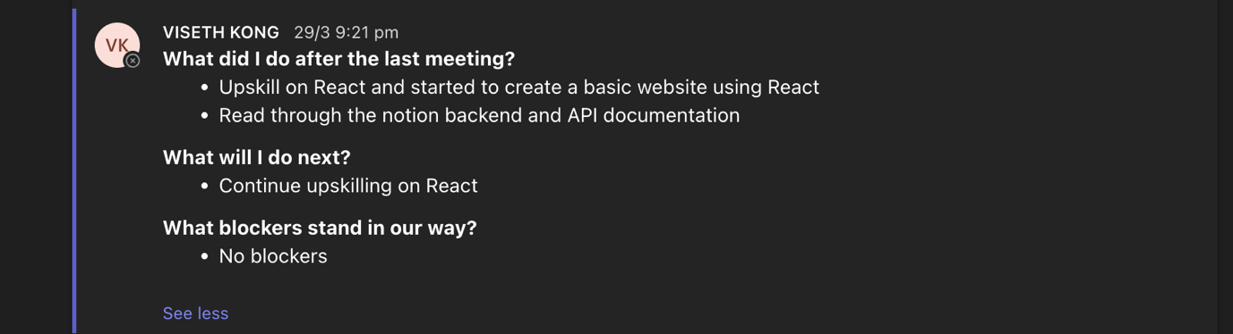

Figure : Progress report

## Thursday (30-March-2022)

* Continue upskilling on React and working on my basic React website

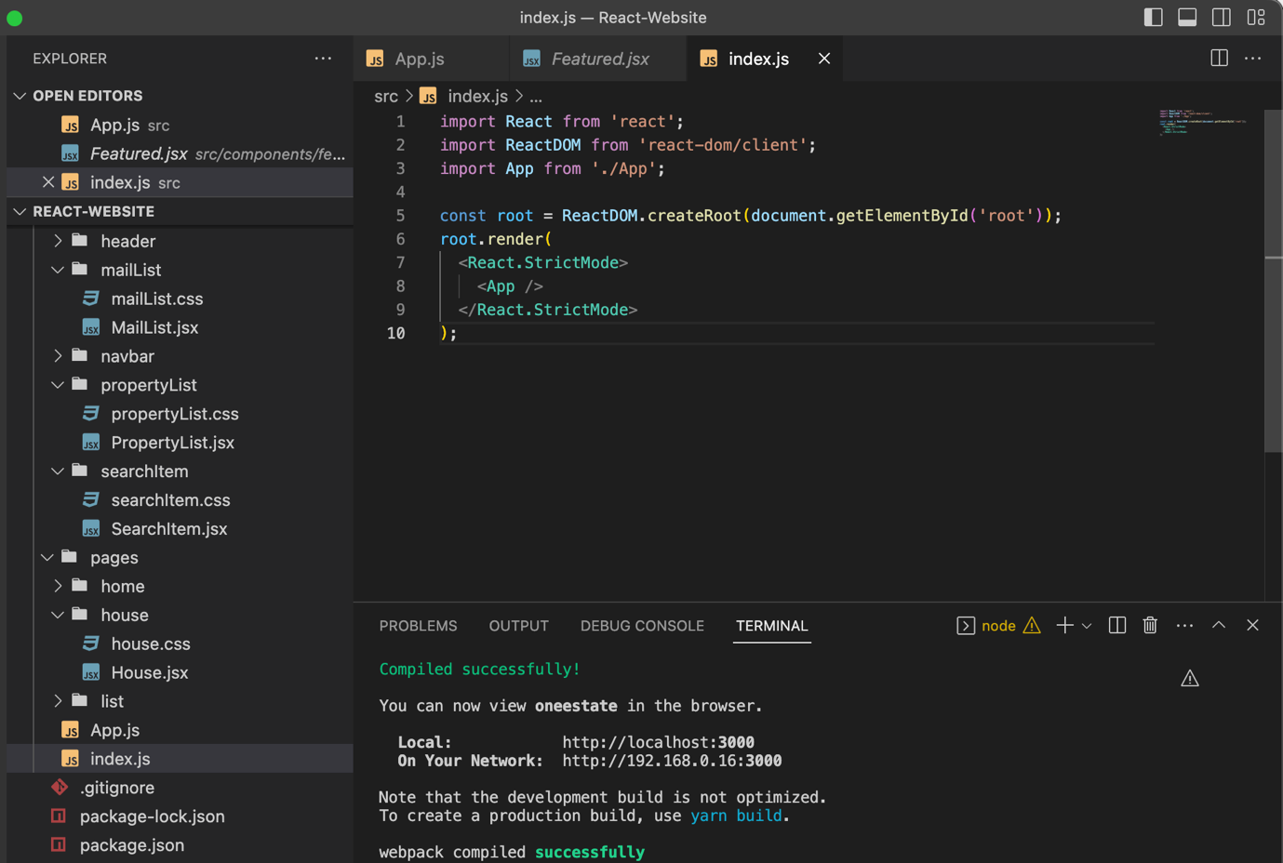

Figure : Continue working on React project

* Join Daily Standup meeting

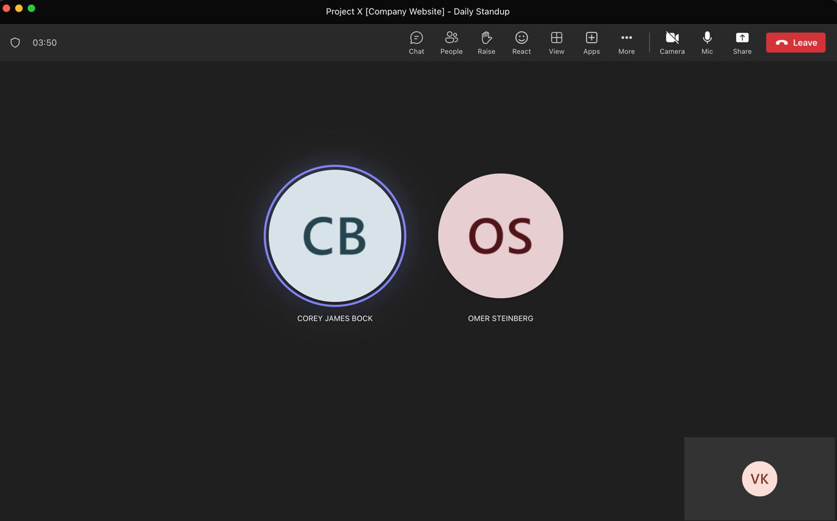

Figure : Daily meeting to provide my progession

## Friday (31-March-2022)

* Continue upskilling on React and completed my basic React website <https://github.com/visethkong/SIT7378-SIT782/tree/main/My-Work-And-Contribution/React-Upskilling>



Figure : Completed a front-end website using React

* Learn how to use GitHub and Git command to clone, add, commit and push.

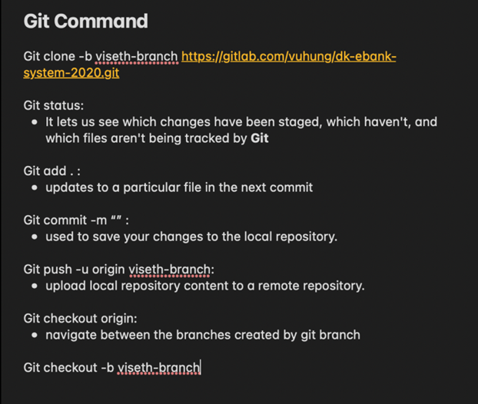

Figure 16: Git Command Notes

Week 5